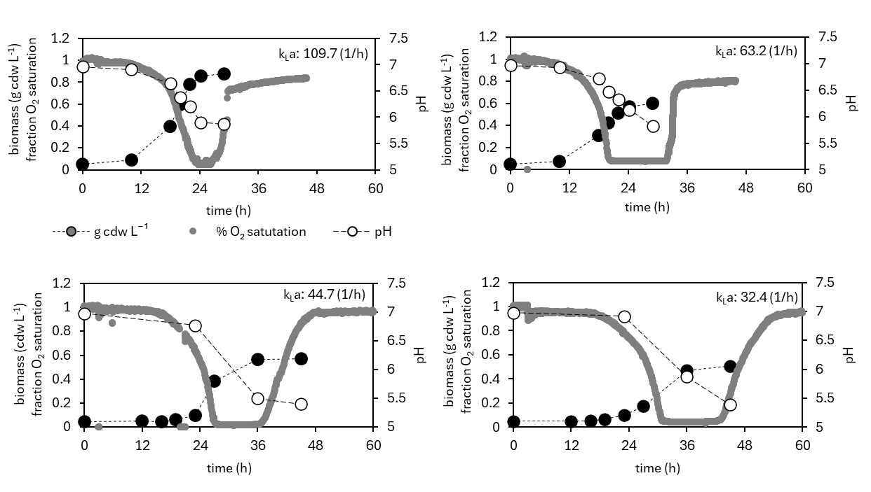

**Supplementary Material S5 Consortia Composition Shifts in Response to O2****Availability.** Cocultures of strains L+R- (517) and L-R+ (515) were inoculated at a 1:1 cell ratio. O2 availability was varied by changing air sparge rates. Fraction saturated O2 was measured with dissolved O2 sensors inside each reactor. Each reactor was 100% air saturated at least two hours prior to inoculation. The pH of the abiotic media was 7±0.05. Stationary phase statistics. Exometabolomics data, culture rates, and culture yields can be found below.

